|  |  |  |
| --- | --- | --- |
| Name: | Period: | Date: |
| Date Started: | Due Date: | |
| Group Members: | | |
| Advanced Design Applications  Learning Cycle 1 Manufacturing Unit 4  DesBriefFile 1.2 Smart Phone Accessory Design Brief | | |

**Smart Phone Accessory Design Brief**

|  |  |
| --- | --- |
| **Background** | Do you find it impossible to keep up with the latest cell phone trends? It seems as though new variations hit the market every day, making it difficult and financially prohibitive for most of us to always have the “latest and greatest.” Well, listen up, trendsetters—there is an affordable and innovative solution for keeping up with the latest trend: accessorize!  In a series of videos linked below, Dr. John Feland, CEO of Argus Insights, provides an overview of the creative process involved in designing a personalized accessory for a smartphone.  **Design Videos:**  <http://digitalsteam.autodesk.com/smartphone-accessory>  First and foremost, you must get to know your customer, since the ultimate goal is to make him or her happy. Research what is already on the market and compare older-model products with newer ones. Summarize the requirements and define parameters. Sketch out as many concepts as possible, always keeping the persona of your customer in mind. Build multiple prototypes and run the best ones by your friends and the customer. Master the art of prototyping and don’t be afraid to fail—because by doing so, you will ultimately succeed in making your customer happy. Following the design process outlined by Dr. Feland in these videos, see if you can design an innovative accessory to spruce up your smartphone. Be creative, try everything. Maybe your design will start a whole new trend! |
| **Design Problem** | Develop a design for an innovative smartphone accessory for mass production based on consumer data. |
| **What to Do:** | As you have learned in this lesson, there are many things that influence the design of a product. Now it’s time to apply that knowledge and gather information about your target customer for your smartphone accessory. You should work in your primary challenge team to collect and organize customer data to develop a design to the problem above.  It’s all about the process! Use the design folio below to fully define your problem, conduct market research and establish a smartphone accessory design based on the consumer needs and wants.  After you have established a rough design for a product based on consumer data, the following learning cycle will involve using design software to create your final product design. |

The teacher may also use the following rubric to evaluate the Engineering Design Process:

| **Category** | **Below Target** | **At Target** | **Above Target** |
| --- | --- | --- | --- |
| **Define Problem** | Rephrases the problem with limited clarity. | Develops a problem statement that includes the who, what, when, and how the problem will be addressed. Recorded in the Engineering Folio or EDJ. | Develops a problem statement that is clearly and precisely stated. The problem statement includes the who, what, when, and how the problem will be addressed. Recorded in the Engineering Folio or EDJ. |
| **Brainstorm Possible Solutions** | Contributes fewer than two or implausible ideas. | Contributes at least two plausible ideas, which are recorded in the Engineering Folio or EDJ. | Contributes at least three plausible ideas, which are expanded upon to show understanding of the concept. All notes are recorded in the Engineering Folio or EDJ. |
| **Research Ideas/ Explore Possibilities** | Contributes ideas, but without documented research. Produces incomplete sketches. | Contributes at least two additional plausible ideas and includes documented research. Produces accurate conceptual models to show the design concepts. All notes are recorded in the Engineering Folio or EDJ. | Contributes at least three additional plausible ideas and includes clearly documented research. Produces accurate conceptual models to show the design concepts with annotated sketches. All notes are recorded in the Engineering Folio or EDJ. |
| **Specify Constraints and Identify Criteria** | Does not identify the criteria and/or fails to specify constraints. | Clearly identifies the criteria and specifies the constraints listed in the design specifications. All notes are recorded in the Engineering Folio or EDJ. | Clearly identifies the criteria and specifies the constraints that are listed in the design specifications and some that are not but pertain to their suggested design. All notes are recorded in the Engineering Folio or EDJ. |
| **Consider Alternative Solutions** | Inadequate analysis of a variety of possible solutions. | Satisfactorily analyzes a variety of possible solutions, based on research and the relationship of those designs to the criteria and constraints. All notes are recorded in the Engineering Folio or EDJ. | Clearly did not enter the research phase with a preconceived idea of the final design. Thoroughly analyzes a variety of possible solutions, based on research and the relationship of those designs to the criteria and constraints. All notes are recorded in the Engineering Folio or EDJ. |
| **Select an Approach** | Selection of solution is not justified based on consideration of criteria and constraints or a quantitative evaluation method was not used. | Selects and justifies a promising solution based on the problem statement as well as the criteria and constraints. Uses a quantitative evaluation method to determine the final design. All notes are recorded in the Engineering Folio or EDJ. | Selects and thoroughly justifies a promising solution based on the problem statement, criteria, and constraints as well as evidence collected through research. Uses a quantitative evaluation method to determine the final design. All notes are recorded in the Engineering Folio or EDJ. |

| **Category** | **Below Target** | **At Target** | **Above Target** |
| --- | --- | --- | --- |
| **Develop a Written Design Proposal** | Design proposal is inadequate and lacking pertinent information. | Design proposal contains a problem statement. It includes how the solution will be developed and/or how the solution will be evaluated and/or what tests will be conducted to determine success. Includes accurately drawn annotated sketches, notes, and technical drawings. Recorded in the Engineering Folio or EDJ. | Design proposal is written technically and precisely and contains a clear and accurate problem statement. How the solution will be developed as well as how the solution will be evaluated and what tests will be conducted to determine success are included. Includes detailed and accurately drawn annotated sketches, notes, and technical drawings. Recorded in the Engineering Folio or EDJ. |
| **Make Model/ Prototype** | Student builds a working model that *does not align/minimally aligns* with the criteria, constraints, and intent of the problem. The model cannot be tested OR does not work. | Student builds a working model that *adequately* aligns with the criteria, constraints, and intent of the problem. The working model can be tested using appropriate tools, materials, and resources. | Student builds a working model that *excellently* aligns with the criteria, constraints, and intent of the problem.  The working model can be tested using appropriate tools, materials, and resources. |
| **Test and Evaluate** | Student tests the working model’s effectiveness to solve the problem. *Minimal* records are collected or records are mostly inaccurate. Analysis of data is *not* present. | Student tests the working model’s effectiveness to solve the problem. *Adequate*, mostly accurate, records are collected and an analysis of data is present. | Student tests the working model’s effectiveness to solve the problem. Excellent, *accurate and detailed,* records are collected and a thorough analysis of data is present. |
| **Refine/ Improve** | Student does *not* redesign the working model to align with the criteria, constraints, or intent of the problem. | Student redesigns the working model into a more effective solution that aligns with the criteria, constraints, and intent of the problem. | Student clearly *uses data* to redesign the working model into a more effective solution that aligns with the criteria, constraints, and intent of the problem. |
| **Create/Make Product** | Student does not create or make a product that aligns with criteria, constraints, or intent of the problem. | Student makes a final product that aligns with most criteria, constraints, and the intent of the problem. | Student makes a final product that aligns with all criteria, constraints, and the intent of the problem. |
| **Communicate Results** | Student is inadequately prepared to explain the solution and/or results from testing are summarized or shared, but are incomplete or not clearly communicated. | Student is adequately prepared to explain the solution and results from testing are summarized and communicated clearly. | Student is thoroughly prepared to explain the solution. The explanation addresses all criteria, constraints, and solutions. Results from testing are summarized and communicated clearly and effectively. |

|  |  |  |
| --- | --- | --- |
| Name: | Period: | Date: |
| Date Started: | Due Date: | |
| Group Members: | | |
| Advanced Design Applications  Manufacturing Unit  Learning Cycle 1: Under Pressure  Smart Phone Case Design Folio | | |



1. Define the Problem

Develop a problem statement that identifies the what, who, when and how the problem should be addressed.

|  |
| --- |
| Determine the following for your smartphone accessory.   * Purpose: ____________________________________________ * Target audience: _____________________________________ * Size limitations: ______________________________________ * Materials to be used: __________________________________ * Scheduling requirements: ______________________________ * Sale Price: ___________________________________________   Example statement for a new evening purse design:   * Target audience: Female, 20s to 30s. * Size limitations: Small enough to hold in one hand, but must be able to hold essential items (driver’s license, cash or credit cards, small mirror and lipstick.) * Materials to be used: Lightweight fabric/leather/vinyl, strong, attractive/stylish. * Scheduling requirements: 6 to 10 hours to complete * Sale Price: Under $20.00 U.S. |

1. Brainstorming

List/sketch possible ideas for a smartphone accessory that might be used in your final design. Clearly identify and describe how each of these ideas relates to the problem statement.

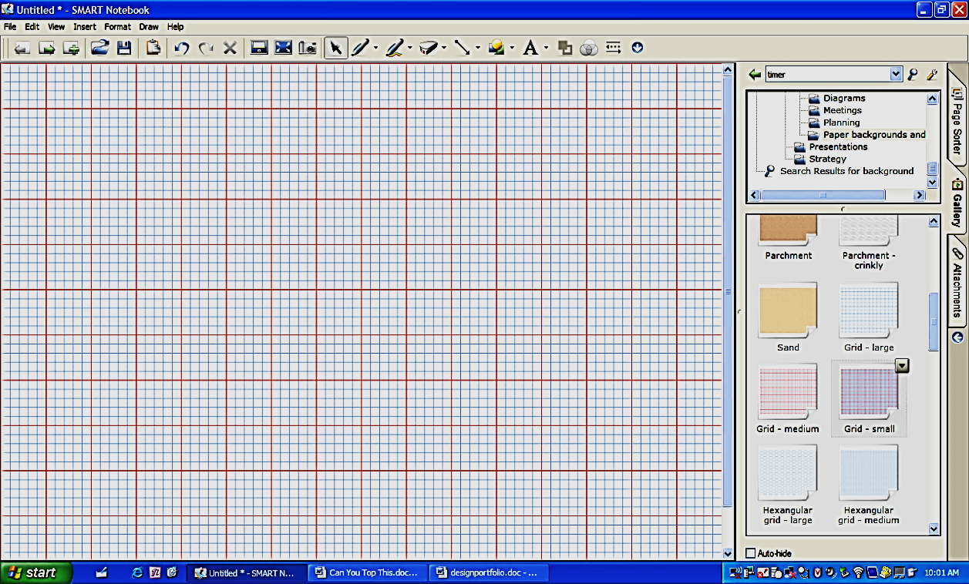

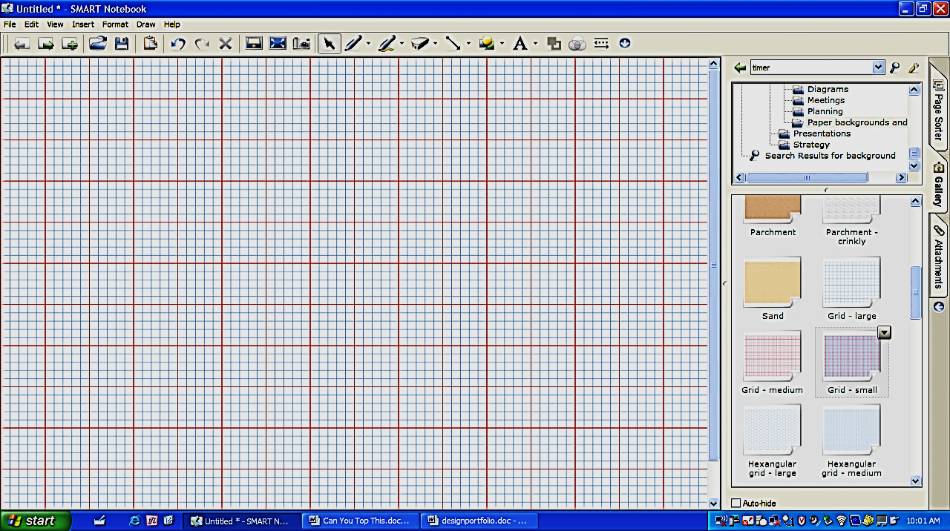

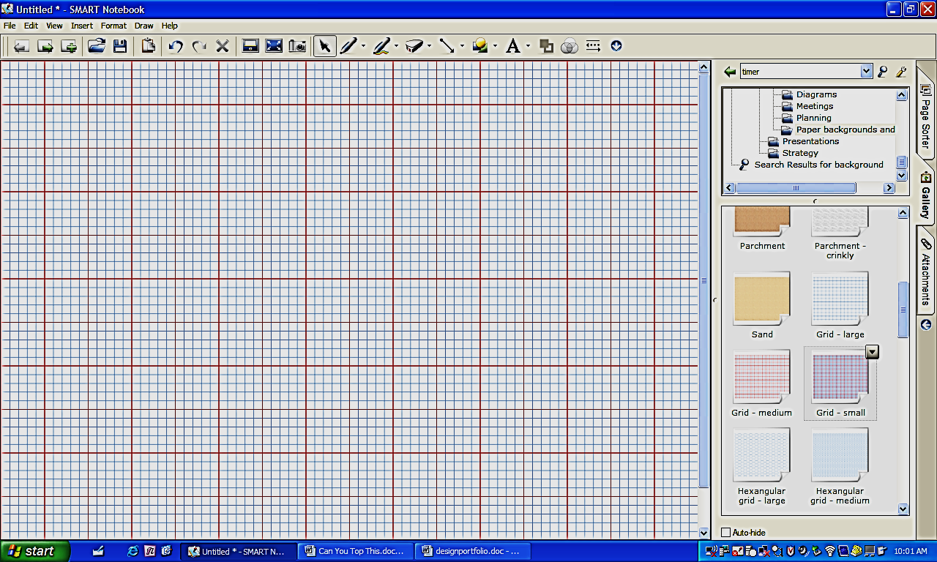

1. Research and generating ideas

In the space below, document your research. Be sure to include proper citations at the end of your notes.

|  |
| --- |
| **Market Research** |
| “Design thinking” linked to a smartphone accessory project starts by formulating and answering some key questions:   * Who makes up the potential target market for the customized accessory? * What are some of the key functional, emotional, and psychological needs of the target market? * What other competitive products are already on the market? * What purpose(s) will the accessory serve? * How much will the accessory sell for? * Has a budget been established for the project? * What is your schedule for completion? * What inspires you about this project? |
|  |
| **Consumer Survey** |
| Each team should generate a questionnaire with at least seven questions related to the selection or preferences of the desired smartphone accessory. Each team must analyze the data to determine the most important factor to consider as you create your smartphone design. At a minimum you should:   1. Identify your sample size. 2. Calculate the statistical mode for each response for each question. 3. Determine how these responses are distributed by gender. |

1. Identifying criteria and specifying constraints

What are the criteria and constraints of the design problem?

|  |
| --- |
| Now we need to establish design criteria and constraints based on consumer data. In order to develop innovative project solutions, it is critical that you develop a clear understanding of all relevant design criteria. The following will help you identify important factors that shape this project by prompting a response to questions in four key categories: who, where, what, and why. |
| WHO  **Who will be the end user of the smartphone accessory?**   * What will they use it to do? * What are their physical design requirements for the accessory interface? * What are some key physical requirements for the convenience of the user? * Will there be a broad base of users or a very specific target group?   **Who will interact with the accessory and the accessory user?**   * What are the design requirements that are necessary for these users? * What are some key physical requirements for the demands of this group of users? * How will they interact with the accessory and the accessory user?   **Who will own the accessory?**   * What is the budget for repairs and operation? * How long will they want to use the accessory? * How would you describe their aesthetic preferences with respect to the accessory’s design?   **Who will be indirectly affected by the production and use of the application?**   * How might the accessory affect different groups in incidental ways? * What concerns might they have?   **Who has regulatory influence over product safety, materials used, radio emissions, and so on?**   * What concerns might they have that will impact their decisions about type, size, and location? * What concerns might they have that the manufacturer must take into account when designing the product?   **Who will disassemble the product and reuse materials after the accessory reaches the end of its functional life?**   * Who would want to use the parts that still function from the accessory? * Who will be responsible for collecting the accessory after it’s been used? The user? The recycler?   WHERE  **Where will the accessory be used?**   * What is the intended operating environment for the accessory? * Will it be used indoors or outdoors? * How does the accessory affect the immediate area in which it is used (noise, emissions)? * How does its portable nature affect the design requirements? * Where are the largest potential markets for the product? * Will this be used in international markets or just in one country? How will this affect the design?   **Where will the accessory be constructed?**   * Will the accessory be built all in one place? * Will the accessory be pre-manufactured and assembled at a different location? * Will it be built in the country or in a different country?   WHAT  **What types of materials are best suited for the smartphone accessory?**   * Will the accessory require materials that are durable? * Will the materials have to reflect a certain type of aesthetic? * Will the budget limit the type of materials that can be used? * Will certain materials pose a danger to the user or those who interact with the accessory? * Can recycled materials be used?   **What types of designs and manufacturing methods are best suited for a smartphone accessory?**   * What skills and equipment will the manufacturers have?   **What types of functionality will the design have to deliver?**   * What characteristics of the accessory affect its functioning and its performance? * Will the product be customizable? To what extent?   WHY  **Why is the client interested in designing and using a smartphone accessory?**   * Will the accessory be used for commercial purposes? * Will the accessory be manufactured just for personal use or for mass production? * Why will mass customization be a part of your accessory or not? * Will the accessory be a social or status symbol as well as a functional accessory?   **Why is a smartphone accessory a useful product to design at this time?**   * What potential large-scale effect do you see that your accessory might create? * How does the increasing availability of portable technology affect our lives? |

|  |  |
| --- | --- |
| **List the specific criteria and constraints for your smartphone Accessory** | |
| **Criteria** | **Constraints** |
|  |  |

1. Exploring possibilities

Reflect on your brainstormed ideas and research notes and describe the plusses and minuses of each design approach you have considered. Is there an alternative solution you did not consider?

|  |  |  |
| --- | --- | --- |
| **Brainstorming Idea** | **Pluses** | **Minuses** |
| **Idea 1** |  |  |
| **Idea 2** |  |  |
| **Idea 3** |  |  |

|  |
| --- |
| **Did alternative solutions arise as you initially evaluated your designs? Cite examples.** |
|  |

1. Selecting an approach
   1. Enter the constraints and criteria of the project in the first column.
   2. Score your brainstorming ideas against each constraint or criterion and indicate how well the idea meets the criteria and constraints.

3 pts = easily meets, 2 pts = somewhat meets, 1 pt = does not meet

* 1. Total the columns and circle the highest score to indicate your best design idea.

**3 pts = easily meets, 2 pts = somewhat meets, 1 pt = does not meet**

|  |  |  |  |  |  |  |
| --- | --- | --- | --- | --- | --- | --- |
| **Constraint/Criterion** | **Rate your**  **Brainstormed Ideas (3, 2, 1)** | | | | | |
| **1** | **2** | **3** | **4** | **5** | **6** |
|  |  |  |  |  |  |  |
|  |  |  |  |  |  |  |
|  |  |  |  |  |  |  |
|  |  |  |  |  |  |  |
|  |  |  |  |  |  |  |
|  |  |  |  |  |  |  |
|  |  |  |  |  |  |  |
|  |  |  |  |  |  |  |
| **Total** |  |  |  |  |  |  |

|  |
| --- |
| **Justify the solution -** Write a short paragraph justifying your solution. Include trade-offs that were made in the selection. |
|  |

1. Developing a design proposal

Take your highest-scoring brainstorming ideas and create working drawings (sketches with dimensions so that you could build your project) of your complete device. Attach your working drawings to this sheet.

|  |  |
| --- | --- |
| **Material to be Used** | **Qty** |
|  |  |
|  |  |
|  |  |
|  |  |
|  |  |
|  |  |
|  |  |
|  |  |

1. Make Model/Prototype

Record the various tools, processes, and materials you will employee to achieve your solution.

|  |  |  |
| --- | --- | --- |
| **Tools and Machines** | **Processes** | **Material** |
|  |  |  |
|  |  |  |
|  |  |  |
|  |  |  |
|  |  |  |
|  |  |  |
|  |  |  |
|  |  |  |
|  |  |  |
|  |  |  |
|  |  |  |

1. Test and Evaluate

Compare actual results to desired results

What attributes of your smartphone case design solved the problem?

___________________________________________________________________________________________________________________________________________________________________________________________________________________________________________________________________________________________________________________________

What attributes of your smartphone case design needed improvements? Describe possible changes you would make to a future model or prototype.

___________________________________________________________________________________________________________________________________________________________________________________________________________________________________________________________________________________________________________________________

1. Refine/Improve

Identify the problems you encountered with your solution and the modifications you used to overcome them. Then check the column to determine if your modifications made the design better.

|  |  |  |  |
| --- | --- | --- | --- |
| Deficiencies of Design | Modifications | Better Results | Worse Results |
|  |  |  |  |
|  |  |  |  |
|  |  |  |  |
|  |  |  |  |
|  |  |  |  |
|  |  |  |  |

1. Create/Make Product

Attach a photograph of your finished project below. Describe your project in a way that would allow someone unfamiliar with the assignment to understand it.

____________________________________________________________________________________________________________________________________________________________________________________________________________________________________________________________________________________________________________________________________________________________________________________________________________________________________________________________________________________________________________________________________________________________________________________________________________________________________________________________________________________

**12. Communicate Results**

What is the “Big Idea”? What understandings or concepts related to math, science, and technology influenced the success of my project?

________________________________________________________________________________________________________________________________________________________________________________________________________________________________________________________________________________________________________________________________________________________________________________________________________________________________________________________________________________________________________________________________________________________________________________________________________________________________________________________________________________________________________________________________________________________________________________________________________________________________________________________________________________________________________________________________________________________________________________________________________________________________________________________________________________________________________________________________________________________________________________________________________________________________________________________________________________________________________________________________________________________________________________________________________________________________________________________________________________________________________________________________________________________________________________________________________________________________________________________________________________________________________________________________________________________________________________________________________________________________________________________________________________________________________________________